Growing Pipes
The diagram shows the first three patterns in a sequence in which each pattern has a square hole in the middle.
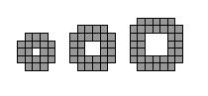
How many small shaded squares are needed to build the tenth pattern in the sequence?

